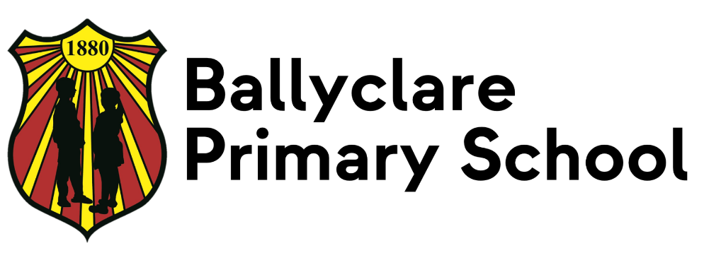


Safeguarding & Child Protection Policy

Date Ratified by Board of Governors: Oct 25
Date of review: June 29

CONTENTS

1 | Our School’s Child Protection Ethos and Key Principles of Safeguarding
2 | Related Policies
3 | The School Safeguarding Team
4 | Definitions of Harm
5 | Responding to a Safeguarding Concern
6 | Consent, Confidentiality, Information Sharing and Record Keeping
7 | Safe Recruitment Procedures
8 | Code of Conduct
9 | The Preventative Curriculum
10 | Monitoring and Evaluation
11 | Appendices
 | Appendix 1 Note of Concern
 | Appendix 2 Specific Types of Abuse
 | Appendix 3 Children with Increased Vulnerabilities
 | Appendix 4 Signs and Symptoms of Child Abuse
 | Appendix 5 If a Parent Has a Potential Child Protection Concern Within the School
 | Appendix 6 Procedure Where the School Has Concerns about Possible Abuse
 | Appendix 7 Dealing with Allegations of Abuse against a Member of Staff
 | Appendix 8 DT & DDT posters
 | Appendix 9 Parent information re Bullying

1 CHILD PROTECTION ETHOS

We in Ballyclare Primary School have a responsibility for the safeguarding and child protection of the children in our care and we will carry out this duty by providing a caring, supportive and safe environment, where each child is valued for his or her unique talents and abilities, and in which all our young people can learn and develop to their full potential. All staff, teaching and non-teaching should be alert to the signs of possible abuse and should know the procedures to be followed. This policy sets out guidance on the action, which is required where abuse or harm to a child is suspected and outlines referral procedures within our school.

Key Principles of Safeguarding and Child Protection

The general principles, which underpin our work, are those set out in the UN Convention on the Rights of the Child and are enshrined in the Children (Northern Ireland) Order 1995, “Co-operating to safeguard children and young people in Northern Ireland” (DHSSPSNI, 2017 and 2024), the Department of Education (Northern Ireland) guidance “Safeguarding and Child Protection in Schools” Circular 2017/04 (and subsequent amendments) and the SBNI Core Child Protection Policy and Procedures (2017).

The following principles form the basis of our Child Protection Policy:

- The child or young person’s welfare is paramount;
- The voice of the child or young person should be heard;
- Parents are supported to exercise parental responsibility and families helped stay together;
- Partnership;
- Prevention;
- Responses should be proportionate to the circumstances;
- Protection; and
- Evidence based and informed decision making.

2 OTHER RELATED POLICIES

The school has a duty to ensure that safeguarding permeates all activities and functions. The child protection policy therefore complements and supports a range of other school policies including:

- Anti-Bullying
- Attendance
- Drugs
- Positive Behaviour Management
- Staff Code of Conduct
- Complaints
- Educational Visits
- Online Safety
- Managing Critical Incidents
- First Aid and Administration of Medicines
- Health and Safety
- Intimate Care
- Records Management
- Relationships and Sexuality Education
- Special Educational Needs
- Use of Mobile Phones/Cameras
- Use of Reasonable Force/Safe Handling
- Whistleblowing

These policies are available to parents and any parent wishing to have a copy should contact the School office.

The following are members of the school’s Safeguarding Team:

- Chair of the Board of Governors: Mr S McLean
- Designated Governor for Child Protection: Mr N. Blair & Mrs F Halliday
- Principal: Mrs K. Mulligan
- Designated Teacher: Mr M. Joyce
- Deputy Designated Teachers: Mrs K. Mulligan, Mrs R. Kennedy, Mrs N. Stewart

ROLES AND RESPONSIBILITIES

Board of Governors must ensure that:

- A Designated Governor for Child Protection is appointed.

- A Designated and Deputy Designated Teacher are appointed in their schools.

- They have a full understanding of the roles of the Designated and Deputy Designated Teachers for Child Protection.

- Safeguarding and child protection training is given to all staff and governors including refresher training.

- Relevant safeguarding information and guidance is disseminated to all staff and governors with the opportunity to discuss requirements and impact on roles and responsibilities.

- The school has a Child Protection Policy which is reviewed annually and parents and pupils receive a copy of the child protection policy and complaints procedure every two years.

- The school has an Anti-Bullying Policy which is reviewed at intervals of no more than four years and maintains a record of all incidents of bullying or alleged bullying. See the Addressing Bullying in Schools Act (NI) 2016.

- Information regarding Bullying is sent to the parents annually (Appendix 9)

- The school ensures that other safeguarding policies are reviewed at least every 3 years or as specified in relevant guidance.

- There is a code of conduct for all adults working in the school.

- All school staff and volunteers are recruited and vetted, in line with DE Circulars.

- They receive a full annual report on all child protection matters and a monthly report of child protection activities. This report should include details of the preventative curriculum and any initiatives or awareness raising undertaken within the school, including training for staff.

- The school maintains the following child protection records in line with DE Circulars 2015/13 Dealing with Allegations of Abuse Against a Member of Staff and 2020/07 Child Protection: Record Keeping in Schools: Safeguarding and child protection concerns; disclosures of abuse; allegations against staff and actions taken to investigate and deal with outcomes; staff induction and training.

The School Safeguarding Team

As best practice, in the best interests of the children, and as a support for the Designated Teachers, the school should establish a Safeguarding Team. This team should include the Chair of the BoG, the Designated Governor for Child Protection, the Principal (as Chair), the DT and the DDT. The team may co-opt other members as required to help address specific issues, for example the SENCO, ICT Co-ordinator, etc. Where schools have employed an individual with social work qualifications/ experience, the postholder may be included in the school safeguarding team. However, only teachers in schools can assume the safeguarding role and responsibilities of the Designated Teacher.

This Safeguarding Team is a vehicle for ensuring effective co-ordination and co-operation between the key individuals responsible for safeguarding throughout the school.

The EA CPSS provides child protection training in relation to the specific responsibilities of each member of the team.

The responsibilities of the team should include:

- The monitoring and periodic review of Safeguarding and Child Protection arrangements in the school.
- Support for the DT in the exercise of their child protection responsibilities, including recognition of the administrative and emotional demands of the post.
- Ensuring attendance of Governors and staff at relevant training - including refresher training - in keeping with legislative and best practice requirements.

Chair of Board of Governors

The Chairperson of the BoG plays a pivotal role in creating and maintaining the safeguarding ethos within the school environment.

In the event of a safeguarding or child protection complaint being made against the Principal, it is the Chairperson who must assume lead responsibility for managing the complaint/allegation in keeping with guidance issued by the Department (and relevant guidance from other Departments when it comes to other early years settings), employing authorities, and the school’s own policies and procedures.

The Chairperson is responsible for ensuring child protection records are kept and for signing and dating annually the Record of Child Abuse Complaints against staff members even if there have been no entries.

The School Principal: Mrs K Mulligan

The Principal, as the Secretary to the BoG, will assist the BoG to fulfil its safeguarding and child protection duties, keeping them informed of any changes to guidance, procedure or legislation relating to safeguarding and child protection, ensuring any circulars and guidance from DE are shared promptly, and timely inclusion of child protection activities on the BoG meeting agenda. In addition, the Principal takes the lead in managing child protection concerns relating to staff.

The Principal has delegated responsibility for establishing and managing the safeguarding and child protection systems within the school. This includes the appointment and management of suitable staff to the key roles of DT and DDT Designated Teacher posts and ensuring that new staff and volunteers have safeguarding and child protection awareness sessions as part of an induction programme.

It is essential that there is protected time and support to allow the DTs to carry out this important role effectively and that DTs are selected based on knowledge and skills required to fulfil the role.

The Principal must ensure that parents and pupils receive a copy, or summary, of the Child Protection Policy at intake and, at a minimum, every two years.

Designated Governor for Child Protection

The BoG delegates a specific member of the governing body to take the lead in safeguarding/child protection issues in order to advise the governors on: -

- The role of the designated teachers;
- The content of child protection policies;
- The content of a code of conduct for adults within the school;
- The content of the termly updates and full Annual Designated Teachers Report;
- Recruitment, selection, vetting and induction of staff.

Designated Teacher for Child Protection: Mr M Joyce

Every school is required to have a DT and DDT with responsibility for child protection. These are highly skilled roles developed and supported through a structured training programme, requiring knowledge and professional judgement on complex and emotive issues. The responsibilities involve:

- The induction and training of all school staff including support staff.
- Annual whole staff Safeguarding and Child Protection training.
- Being available to discuss safeguarding or child protection concerns of any member of staff.
- Having responsibility for record keeping of all child protection concerns.
- Ensuring staff are aware that Notes of Concern should be completed using the template provided in DE circular 2020/07.
- Maintaining a current awareness of early intervention supports and other local services e.g. Family Support Hubs.
- Making referrals to Social Services or PSNI where appropriate.
- Liaison with the EA Designated Officers for Child Protection.
- Keeping the school Principal informed.
- Lead responsibility for the development of the school’s child protection policy.
- Promotion of a safeguarding and child protection ethos in the school.
- Compiling written reports to the BoG regarding child protection

Deputy Designated Teachers for Child Protection: Mrs K Mulligan, Mrs R Kennedy and Mrs N Stewart

The role of the DDT is to work co-operatively with the DT in fulfilling his/her responsibilities.

It is important that the DDT works in partnership with the DT so that he/she develops sufficient knowledge and experience to undertake the duties of the DT when required. DDTs are also provided with the same specialist training by CPSS to help them in their role.

Due to the size of our school, there are 3 Deputy Designated Teachers. The Designated and Deputy Designated Teachers lead the Pastoral Care Team in school.

Other Members of School Staff

- Members of staff must refer concerns or disclosures initially to the Designated Teacher for Child Protection or to the Deputy Designated Teachers if he/she is not available.

- Class teachers and Year Heads should complete the Note of Concern using the paper form (Appendix 1) or electronically via CPOMS if there are safeguarding concerns such as: poor attendance and punctuality, poor presentation, changed or unusual behaviour including self-harm and suicidal thoughts, deterioration in educational progress, discussions with parents about concerns relating to their child, concerns about pupil abuse or serious bullying and concerns about home circumstances including disclosures of domestic abuse.

- Staff should not give children a guarantee of total confidentiality regarding their disclosures, should not investigate nor should they ask leading questions

Support Staff

- If any member of the support staff has concerns about a child or staff member they should report these concerns to the Designated Teacher or Deputy Designated Teacher if he/she is not available. A detailed written record of the concerns will be made and any further necessary action will be taken.

Parents

The primary responsibility for safeguarding and protection of children rests with parents who should feel confident about raising any concerns they have in relation to their child.

- Parents can play their part in safeguarding by informing the school.
- If the child has a medical condition or educational need.
- If there are any Court Orders relating to the safety or wellbeing of a parent or child.
- If there is any change in a child’s circumstances for example - change of address, change of contact details, change of name, change of parental responsibility.
- If there are any changes to arrangements about who brings their child to and from school.
- If their child is absent and should send in a note on the child’s return to school. This assures the school that the parent/carer knows about the absence. More information on parental responsibility can be found on the EA website at: www.eani.org.uk/schools/safeguarding-and-child-protection

It is essential that the school has up to date contact details for the parent/carer.

4 CHILD PROTECTION DEFINITIONS

Definition of Harm

(Co-operating to Safeguard Children and young People in Northern Ireland August 2017)
Harm can be suffered by a child or young person by acts of abuse perpetrated upon them by others. Abuse can happen in any family, but children may be more at risk if their parents have problems with drugs, alcohol and mental health, or if they live in a home where domestic abuse happens. Abuse can also occur outside of the family environment. Evidence shows that babies and children with disabilities can be more vulnerable to suffering abuse.

Although the harm from the abuse might take a long time to be recognisable in the child or young person, professionals may be in a position to observe its indicators earlier, for example, in the way that a parent interacts with their child. Effective and ongoing information sharing is key between professionals.

Harm from abuse is not always straightforward to identify and a child or young person may experience more than one type of harm.

Harm can be caused by:

Sexual abuse
Emotional abuse
Physical abuse
Neglect
Exploitation

SEXUAL ABUSE occurs when others use and exploit children sexually for their own gratification or gain or the gratification of others. Sexual abuse may involve physical contact, including assault by penetration (for example, rape, or oral sex) or non-penetrative acts such as masturbation, kissing, rubbing and touching outside clothing. It may include non-contact activities, such as involving children in the production of sexual images, forcing children to look at sexual images or watch sexual activities, encouraging children to behave in sexually inappropriate ways or grooming a child in preparation for abuse (including via e-technology). Sexual abuse is not solely perpetrated by adult males. Women can commit acts of sexual abuse, as can other children.

EMOTIONAL ABUSE is the persistent emotional maltreatment of a child. It is also sometimes called psychological abuse and it can have severe and persistent adverse effects on a child’s emotional development.

Emotional abuse may involve deliberately telling a child that they are worthless, or unloved and inadequate. It may include not giving a child opportunities to express their views, deliberately silencing them, or ‘making fun’ of what they say or how they communicate. Emotional abuse may involve bullying – including online bullying through social networks, online games or mobile phones – by a child’s peers.

PHYSICAL ABUSE is deliberately physically hurting a child. It might take a variety of different forms, including hitting, biting, pinching, shaking, throwing, poisoning, burning or scalding, drowning or suffocating a child.

NEGLECT is the failure to provide for a child’s basic needs, whether it be adequate food, clothing, hygiene, supervision or shelter that is likely to result in the serious impairment of a child’s health or development. Children who are neglected often also suffer from other types of abuse.

EXPLOITATION is the intentional ill-treatment, manipulation or abuse of power and control over a child or young person; to take selfish or unfair advantage of a child or young person or situation, for personal gain. It may manifest itself in many forms such as child labour, slavery, servitude, and engagement in criminal activity, begging, benefit or other financial fraud or child trafficking. It extends to the recruitment, transportation, transfer, harbouring or receipt of children for the purpose of exploitation. Exploitation can be sexual in nature.

Although ‘exploitation’ is not included in the categories of registration for the Child Protection Register, professionals should recognise that the abuse resulting from or caused by the exploitation of children and young people can be categorised within the existing CPR categories as children who have been exploited will have suffered from physical abuse, neglect, emotional abuse, sexual abuse or a combination of these forms of abuse.

Specific Types of Abuse

In addition to the types of abuse described above there are also some specific types of abuse that we in Ballyclare Primary School are aware of and have therefore included them in our policy. Please see Appendix 2

Children with Increased Vulnerabilities

Some children have increased risk of abuse due to specific vulnerabilities such as disability, lack of fluency in English or sexual orientation. We have included information about children with increased vulnerabilities in our policy. Please see Appendix 3

Signs and Symptoms of Abuse

The definition of signs and symptoms of abuse are taken from Co-operating to Safeguard Children and Young People in NI (October 2024) Appendix 4.

5 Responding to Safeguarding and Child Protection Concerns

Safeguarding is more than child protection. Safeguarding begins with promotion and preventative activity which enables children and young people to grow up safely and securely in circumstances where their development and wellbeing is not adversely affected. It includes support to families and early intervention to meet the needs of children and continues through to child protection. Child protection refers specifically to the activity that is undertaken to protect individual children or young people who are suffering, or are likely to suffer significant harm.

If a parent has a potential child protection concern within the school

In Ballyclare Primary School we aim to work closely with parents/guardians in supporting all aspects of their child’s development and well-being. Any concerns a parent may have will be taken seriously and dealt with in a professional manner.

If a parent has a concern they can talk to the Class Teacher/Year Head, Designated or Deputy Designated Teacher for child protection or the Principal.

If they are still concerned they may talk to the Chair of the Board of Governors.
At any time a parent may talk to a social worker in the local Gateway team or to the PSNI Central Referral Unit. Details of who to contact are shown in the flowchart in Appendix 5

Where School Has Concerns or Has Been Given Information about Possible Abuse by Someone Other Than a Member of Staff

In Ballyclare Primary School if a child makes a disclosure to a teacher or other member of staff which gives rise to concerns about possible abuse, or if a member of staff has concerns about a child, the member of staff will complete a Note of Concern using the paper form (see Appendix 1) or electronically via CPOMS and act promptly. They will not investigate - this is a matter for Social Services - but will discuss these concerns with the Designated Teacher or with the Deputy Designated Teacher if he/she is not available.

The Designated Teacher will consult with the Principal or other relevant staff always taking care to avoid due delay. If required advice may be sought from the Education Authority Designated Officer for Child Protection. The Designated Teacher may also seek clarification from the child or young person, their parent/carer.

If a child protection referral is not required the school may consider other options including monitoring, signposting or referring to other support agencies e.g. Family Support Hub with parental consent and, where appropriate, with the child/young person’s consent.

If a child protection referral is required the Designated Teacher will seek consent from the parent/carer and/or the child {if they are competent to give this} unless this would place the child at risk of significant harm.

The Designated Teacher will phone the Gateway team and/or the PSNI and will submit a completed UNOCINI referral form.

Where appropriate the source of the concern will be informed of the action taken.

For further detail please see Appendix 6

Where a Complaint Has Been Made about Possible Abuse by a Member of the School’s Staff or a Volunteer

When a complaint about possible child abuse is made against a member of staff the Principal (or the Designated Teacher if the Principal is not available) must be informed immediately. If the complaint is against the Principal then the Designated Teacher should be informed and he/she will inform the Chairperson of the Board of Governors who will consider what action is required in consultation with the employing authority. The procedure as outlined in Appendix 7 will be followed.

6 CONSENT

Prior to making a referral to Social Services the consent of the parent/carers and/or the young person (if they are competent to give this) will normally be sought. The exception to this is where to seek such consent would put that child, young person or others at increased risk of significant harm or an adult at risk of serious harm, or it would undermine the prevention, detection or prosecution of a serious crime including where seeking consent might lead to interference with any potential investigation.

In circumstances where the consent of the parent/carer and/or the young person has been sought and is withheld we will consider and where possible respect their wishes. However, our primary consideration must be the safety and welfare of the child and we will make a referral in cases where consent is withheld if we believe on the basis of the information available that it is in the best interests of the child/young person to do so.

Confidentiality and Information Sharing

Information given to members of staff about possible child abuse cannot be held “in confidence”. In the interests of the child, staff have a responsibility to share relevant information about the protection of children with other professionals particularly the investigative agencies. In keeping with the principle of confidentiality, the sharing of information with school staff will be on a ‘need to know’ basis.

Where there have been, or are current, child protection concerns about a pupil who transfers to another school we will follow DE guidance in determining what information should be shared with the Designated Teacher in the receiving school.

Where it is necessary to safeguard children, information will be shared with other statutory agencies in accordance with the requirements of this policy, the school data protection policy and the General Data Protection Regulations (GDPR)

In accordance with DE guidance, we have developed clear guidelines for the recording, storage, retention and destruction of both manual and electronic records where they relate to child protection concerns.

In order to meet these requirements all child protection records, information and confidential notes concerning pupils in Ballyclare Primary School are stored securely and only the Designated Teacher/Deputy Designated Teacher and Principal have access to them. In accordance with DE guidance on the disposal of child protection records these records will be stored from child’s date of birth plus 30 years.

Where information is held electronically using CPOMS, whether on a PC, a laptop or on a portable memory device, all must be encrypted and appropriately password protected.

These notes or records should be factual, objective and include what was seen, said, heard or reported. They should include details of the place and time and who was present and should be given to the Designated/Deputy Designated Teacher. The person who reports the incident must treat the matter in confidence.

If a pupil from our school attends an EOTAS provision, a member of the safeguarding team will share any child protection concerns they have with the DT in the centre. If child protection concerns arise when the pupil is attending an EOTAS provision the designated teacher in EOTAS will follow child protection procedures and will advise a member of the school’s safeguarding team of the concerns and any actions taken. It is the responsibility of EOTAS staff to maintain their records in accordance with DE Circular 2020/07 Child Protection: Record Keeping in Schools and any subsequent updates.
In Ballyclare Primary School we use the C2K approved system CPOMS to record and store child protection information. Access to this system is restricted according to staff status and is managed by the Designated Teacher for Child Protection. The system is encrypted using 2 form authentication for all logins. Full staff training on the use of CPOMS takes place annually and is led by the Designated Teacher for Child Protection. All archived Child Protection folders (Pre 2023/24 year) for current pupils have been uploaded to this system and paper copies of all child protection folders have been retained (in line with Circular 2020/07).

7 SAFE RECRUITMENT PROCEDURES

Vetting checks are a key preventative measure in preventing unsuitable individuals’ access to children and vulnerable adults through the education system and schools must ensure that all persons on school property are vetted, inducted and supervised as appropriate if they are engaged in regulated activity. All staff paid or unpaid who are appointed to positions in Ballyclare Primary School are vetted/supervised in accordance with relevant legislation and Departmental guidance.

8 CODE OF CONDUCT FOR ALL STAFF - PAID OR UNPAID

All actions concerning children and young people must uphold the best interests of the young person as a primary consideration. Staff must always be mindful of the fact that they hold a position of trust and that their behaviour towards the child and young people in their charge must be above reproach. All members of staff are expected to comply with the school’s Code of Conduct (outlined In the staff handbook) for Employees and Volunteers which has been approved by the Board of Governors.
9 THE PREVENTATIVE CURRICULUM

The statutory personal development curriculum requires schools to give specific attention to pupils’ emotional wellbeing, health and safety, relationships, and the development of a moral thinking and value system. The curriculum also offers a medium to explore sensitive issues with children and young people in an age-appropriate way which helps them to develop appropriate protective behaviours. (DE guidance “Safeguarding and Child Protection in Schools” Circular 2017/04 and subsequent amendments).

In Ballyclare Primary School we have a planned programme for PDMU and RSE, in line with the CCEA curriculum and our school ethos. This is progressive across year groups and key stages. Every opportunity is taken to support pupils’ emotional wellbeing, health and safety and positive relationships and this includes taking advantage of non-curricular opportunities such as responding to situations that arise on a daily basis inside and outside the classroom.

Our school seeks to promote pupils’ awareness and understanding of safeguarding issues, including those related to child protection through its curriculum. The safeguarding of children is an important focus in the school’s personal development programme and is also addressed where it arises within the context of subjects. Through the preventative curriculum we aim to build the confidence, self-esteem and personal resiliencies of children so that they can develop coping strategies and can make more positive choices in a range of situations.

Throughout the school year child protection issues are addressed through assemblies and there is a permanent child protection notice board in the main entrance and relevant information throughout the school, which provides advice and displays child helpline numbers. Posters showing the Designated and Deputy Designated Teachers are displayed throughout the school, including in each classroom (Appendix 8). Other initiatives which address child protection and safety issues include visits to school from relevant authorities such as the NIFRS, PSNI and School Nursing Team.

10 MONITORING AND EVALUATION

This policy will be reviewed annually by the Safeguarding Team and approved by the Board of Governors for dissemination to parents, pupils and staff. It will be implemented through the school’s staff induction and training programme and as part of day-to-day practice. Compliance with the policy will be monitored on an on-going basis by the Designated Teacher for Child Protection and periodically by the Schools Safeguarding Team. The Board of Governors will also monitor child protection activity and the implementation of the Safeguarding and Child Protection policy on a regular basis through the provision of reports from the Designated Teacher.

Date Policy Reviewed:
Signed: | Designated Teacher
Signed: | Principal
Signed: | Chair of Board of Governors

Appendix 1
CONFIDENTIAL

NOTE OF CONCERN

Child Protection Record - Reports to Designated Teacher

Name of Pupil:

Year Group:

Date, Time of Incident/Disclosure:

Circumstances of Incident/Disclosure:

Nature And Description Of Concern:

Parties involved, including any witnesses to an event and what was said or done and by whom:

Action Taken At The Time:

Details Of Any Advice Sought, From Whom And When:

Any Further Action Taken:

Written Report Passed To Designated Teacher: Yes: No:

If ‘No’ state reason:
Date And Time Of Report To The Designated Teacher:

Written Note From Staff Member Placed On Pupil’s Child Protection File

Yes No

If ‘No’ state reason:

Name of Staff Member Making the Report: ______________________________
Signature of Staff Member: __________________________ Date: ____________
Signature of Designated Teacher: ____________________ Date: __________

APPENDIX 2 Specific Types of Abuse

Grooming of a child or young person is always abusive and/or exploitative. It often involves perpetrator(s) gaining the trust of the child or young person or, in some cases, the trust of the family, friends or community, and/or making an emotional connection with the victim in order to facilitate abuse before the abuse begins. This may involve providing money, gifts, drugs and/or alcohol or more basic needs such as food, accommodation or clothing to develop the child’s/young person’s loyalty to and dependence upon the person(s) doing the grooming. The person(s) carrying out the abuse may differ from those involved in grooming which led to it, although this is not always the case. Grooming is often associated with Child Sexual Exploitation (CSE) but can be a precursor to other forms of abuse. Grooming may occur face to face, online and/or through social media, the latter making it more difficult to detect and identify.

Adults may misuse online settings e.g. chat rooms, social and gaming environments and other forms of digital communications, to try and establish contact with children and young people or to share information with other perpetrators, which creates a particular problem because this can occur in real time and there is no permanent record of the interaction or discussion held or information shared. Those working or volunteering with children or young people should be alert to signs that may indicate grooming and take early action in line with their child protection and safeguarding policies and procedures to enable preventative action to be taken, if possible, before harm occurs. Practitioners should be aware that those involved in grooming may themselves be children or young people and may be acting under the coercion or influence of adults. Such young people must be considered victims of those holding power over them. Careful consideration should always be given to any punitive approach or ‘criminalising’ young people who may, themselves, still be victims and/or acting under duress, control, threat, the fear of, or actual violence. In consultation with the PSNI and where necessary the PPS, HSC professionals must consider whether children used to groom others should be considered a child in need or requiring protection from significant harm

If the staff in Ballyclare Primary School become aware of signs that may indicate grooming, they will take early action and follow the school’s child protection policies and procedures. The HSCT and PSNI should be involved as early as possible to ensure any evidence that may assist prosecution is not lost and to enable a disruption plan to reduce the victim’s contact with the perpetrator(s) and reduce the perpetrator(s) control over the victim to be put in place without delay.

Child Sexual Exploitation (CSE) is a form of child sexual abuse. It occurs where an individual or group takes advantage of an imbalance of power to coerce, manipulate or deceive a child or young person under the age of 18 into sexual activity (a) in exchange for something the victim needs or wants, and/ or (b) for the financial advantage or increased status of the perpetrator or facilitator. The victim may have been sexually exploited even if the sexual activity appears consensual. Child sexual exploitation does not always involve physical contact; it can also occur through the use of technology. (Co-operating to Safeguard Children and Young People in NI. DHSSPS version 2.0 2017).

Any child under the age of eighteen, male or female, can be a victim of CSE. Although younger children can experience CSE, the average age at which concerns are first identified is 12-15 years of age. Sixteen- and seventeen-year-olds, although legally able to consent to sexual activity can also be sexually exploited.

CSE can be perpetrated by adults or by young people’s peers, on an individual or group basis, or a combination of both, and can be perpetrated by females as well as males. While children in care are known to experience disproportionate risk of CSE, the majority of CSE victims are living at home.

Statutory Responsibilities

CSE is a form of child abuse and, as such, any member of staff suspecting that CSE is occurring will follow the school’s child protection policy and procedures, including reporting to the appropriate agencies.

Domestic and Sexual Abuse

The NI Domestic and Sexual Abuse strategy 2024 - 2031 defines domestic and sexual violence and abuse as follows: -

Domestic Abuse is:
Threatening, controlling, coercive behaviour, violence or abuse (psychological, virtual, physical, verbal, sexual, financial or emotional) inflicted on anyone (irrespective of age, ethnicity, religion, gender, gender identity, sexual orientation or any form of disability) by a current or former intimate partner or family member

Sexual Abuse is:
Any behaviour (physical, psychological, verbal, virtual/online) perceived to be of a sexual nature which is controlling, coercive, exploitative, harmful, or unwanted that is inflicted on anyone (irrespective of age, ethnicity, religion, gender, gender identity, sexual orientation or any form of disability).

If it comes to the attention of school staff that domestic and /or sexual violence and abuse, is or may be, affecting a child this will be passed on to the Designated/Deputy Designated Teacher who has an obligation to share the information with the Social Services Gateway Team.

Operation Encompass
We are an Operation Encompass school. Operation Encompass is an early intervention partnership between local Police and our school, aimed at supporting children who are victims of domestic violence and abuse. As a school, we recognise that children’s exposure to domestic violence is a traumatic event for them.

Children experiencing domestic abuse are negatively impacted by this exposure. Domestic abuse has been identified as an Adverse Childhood Experience and can lead to emotional, physical and psychological harm. Operation Encompass aims to mitigate this harm by enabling the provision of immediate support. This rapid provision of support within the school environment means children are better safeguarded against the short, medium and long-term effects of domestic abuse.

As an Operation Encompass school, when the police have attended a domestic incident and one of our pupils is present, they will contact the school at the start of the next working day to share this information with a member of the school safeguarding team. This will allow the school safeguarding team to provide immediate emotional support to this child as well as giving the designated teacher greater insight into any wider safeguarding concerns.

This information will be treated in strict confidence, like any other category of child protection information. It will be processed as per DE Circular 2020/07 ‘Child Protection Record Keeping in Schools’ and a note will be made in the child’s child protection file. The information received on an Operation Encompass call from the Police will only be shared outside of the safeguarding team on a proportionate and need to know basis. All members of the safeguarding team will complete online Operation Encompass training, so they are able to take these calls. Any staff responsible for answering the phone at school will be made aware of Operation Encompass and the need to pass these calls on with urgency to a member of the Safeguarding team.

Further information about The Domestic Abuse Information Sharing with Schools etc. Regulations (Northern Ireland) 2022 can be found by following the link to: https://www.legislation.gov.uk

Female Genital Mutilation (FGM) is a form of child abuse and violence against women and girls. FGM comprises all procedures that involve partial or total removal of the external female genitalia, or other injury to the female genital organs for non-medical reasons. The procedure is also referred to as ‘cutting’, ‘female circumcision’ and ‘initiation’. The practice is medically unnecessary, extremely painful and has serious health consequences, both at the time when the mutilation is carried out and in later life. FGM is a form of child abuse and, as such, teachers have a statutory duty to report cases, including suspicion, to the appropriate agencies, through agreed established procedures set out in our school policy. Where there is a concern that a child or young person may be at immediate risk of FGM this should be reported to the PSNI without delay. Contact can be made directly to the Sexual Referral Unit (based within the Public Protection Unit) at 028 9025 9299. Where there is a concern that a child or young person may be at risk of FGM, referral should be made to the relevant HSCT Gateway Team.

Forced Marriage is a marriage conducted without the valid consent of one or both parties and where duress is a factor. Duress can include physical, psychological, financial, sexual and emotional pressure. Forced marriage is a criminal offence in Northern Ireland and if in Ballyclare Primary School we have knowledge or suspicion of a forced marriage in relation to a child or young person we will contact the PSNI immediately.

Children Who Display Harmful Sexual Behaviour

Learning about sex and sexual behaviour is a normal part of a child’s development. It will help them as they grow up, and as they start to make decisions about relationships. As a school we support children and young people, through the Personal Development element of the curriculum, to develop their understanding of relationships and sexuality and the responsibilities of healthy relationships. Teachers are often therefore in a good position to consider if behaviour is within the normal continuum or otherwise.

It must also be borne in mind that sexually harmful behaviour is primarily a child protection concern. There may remain issues to be addressed through the school’s positive behaviour policy but it is important to always apply principles that remain child centred.

It is important to distinguish between different sexual behaviours - these can be defined as normal, inappropriate, problematic, abusive or violent. Healthy sexual behaviour will generally have no need for intervention, however consideration may be required as to appropriateness within a school setting. Problematic sexual behaviour requires some level of intervention, depending on the activity and level of concern. If the behaviour is considered to be more serious advice from the EA CPSS should be sought.

Normal sexual behaviour will generally have no need for intervention; however, consideration may be required as to appropriateness within a school setting.
Inappropriate sexual behaviour requires some level of intervention, depending on the activity and level of concern. For example, a one-off incident may simply require liaising with parents on setting clear direction that the behaviour is unacceptable, explaining boundaries and providing information and education. However, if the behaviour is considered to be more serious, perhaps because there are a number of aspects of concern, advice from the EA Child Protection Support Service (CPSS) may be required. The CPSS will advise if contact with PSNI or Social Services is required.

Problematic, abusive and violent sexual behaviours are of significant concern and guidance on the management of the pupils within the school and referral to other agencies such as the PSNI or Social Services will be sought from CPSS.

We will also take guidance from DE Circular 2022/02 to address concerns about harmful sexualised behaviour displayed by children and young people.

Online safety
Online safety means acting and staying safe when engaging in the online world. It is wider than simply internet technology and includes electronic communication via text messages, making comments on social media posts, social environments and apps, and using games consoles through any digital device. In all cases, in schools and elsewhere, it is a paramount concern.

The overall strategic direction for child safety online is the Keeping Children and Young People Safe: An Online Safety Strategy, published in February 2021. It sets out the Northern Ireland Executive's ambition that all children and young people enjoy the educational, social and economic benefits of the online world, and that they are empowered to do this safely, knowledgably and without fear.

The Strategy recognises that the ever-changing and fast-growing online environment presents both extensive educational benefits as well challenges in terms of keeping children and young people safe from the dangers of inappropriate communication and content.

For further information see: Online Safety Hub - Safeguarding Board for Northern Ireland (safeguardingni.org)

We in Ballyclare Primary School have a responsibility to ensure that there is a reduced risk of pupils accessing harmful and inappropriate digital content and will be energetic in teaching pupils how to act responsibly and keep themselves safe. As a result, pupils should have a clear understanding of online safety issues and, individually, be able to demonstrate what a positive digital footprint might look like.

The school’s actions and governance of online safety are reflected clearly in our safeguarding arrangements. Safeguarding and promoting pupils’ welfare around digital technology is the responsibility of everyone who comes into contact with the pupils in the school or on school-organised activities.

The school has a comprehensive UICT policy that addresses issues of Safeguarding & Child Protection with proactive strategies that form part of our Preventative Curriculum. The school recognises the associated risks around online safety under four categories;
Content risks– the child is exposed to harmful behaviour.
Contact risks – the child participates in adult initiated online activity.
Conduct risks – the child is a perpetrator or victim in peer-to-peer exchange.
Commercial risks – the child is exposed to inappropriate commercial advertising, marketing schemes or hidden costs.
The school has in place a vision for the use of ICT and associated UICT policies and procedures.
Staying Safe Online education forms an important part of the preventative curriculum provided for the children and procedures are in place for the children to report unhealthy or concerning messages or images they may receive. A Safer Internet Day in school also helps highlight safe use of the internet and teaches the children about the dangers of sharing personal images or details. An Acceptable Use of the Internet and Digital Technologies document for pupils and staff is in place as is an agreement for responsible use for pupils and parents to sign. This agreement highlights rules and responsibilities for all users. Parents/carers are provided with extensive advice and information/messages to help keep their child safe online. The school provides advice to staff regarding their personal online activity and has strict rules regarding online contact and electronic communication with pupils. Staff found to be in breach of these rules may be subject to BOG disciplinary action or child protection investigation.
Sharing Nudes and Semi-Nudes

Sharing nudes and semi-nudes is a term used to describe the sending or posting of
naked or partially naked images, videos or livestreams online by young people under
the age of 18. This could be via text, email, social media and gaming platforms, chat
apps or forums. Sharing nudes is sometimes called ‘sexting’, however this term is often
used by young people to talk about sharing sexual messages and not imagery.

Sharing nudes and semi-nudes between individuals in a relationship
As adults we can question the wisdom of this, but the reality is that children consider this to be normal and often the result of a child’s natural curiosity about sex and their exploration of relationships. As a consequence, engaging in the taking or sharing of nudes and semi-nudes may not always be in a ‘harmful’ context. Nonetheless, staff must be aware that an image can be shared non-consensually, or a child can be groomed, tricked or coerced into sending nude and semi-nude images. Clearly pupils need to be aware that it is illegal, under the Sexual Offences (NI) Order 2008, to take, possess or share ‘indecent images’ of anyone under 18 even if they are the person in the picture (or even if they are aged 16+ and in a consensual Specific Types of Abuse Specific Types of Abuse 50 51 relationship) and in these cases you should contact local PSNI on 101 for advice and guidance. Please be aware that, while offences may technically have been committed by the child/children involved, the matter will be dealt with sensitively and considering all the circumstances and it is not necessarily the case that they will end up with a criminal record. It is important that particular care is taken in dealing with any such cases. Adopting scare tactics may discourage a child from seeking help if they feel entrapped by the misuse of sexual images. Advice should be sought from CPSS

Sharing an Inappropriate Image with an Intent to Cause Distress
If a child has been affected by inappropriate images or links on the internet it is important that you do not forward it to anyone else. Please remember that schools are not required to investigate incidents. It is an offence under the Criminal Justice and Courts Act 2015 (Criminal Justice and Courts Act 2015) to share an inappropriate image of another person without the individual’s consent - see Articles 33-35 of the Act for more detail. By contacting the PSNI you could help prevent further distribution of the image and further such incidents contain the damage it can cause. If a child has shared an inappropriate image of themselves that is now being shared further whether or not it is intended to cause distress, the child protection procedures should be followed. For further information see: www.legislation.gov.uk/ukpga/2015/2/section/33/enacted

If a young person has shared an inappropriate image of themselves that is now being shared further whether or not it is intended to cause distress, the child protection procedures of the school will be followed.

The main forms of abuse are:
Physical abuse
Physical abuse is the use of physical force or mistreatment of one person by another which may or may not result in actual physical injury. This may include hitting, pushing, rough handling, exposure to heat or cold, force feeding, improper administration of medication, denial of treatment, misuse or illegal use of restraint and deprivation of liberty.
Sexual Violence and Abuse
Sexual abuse is any behaviour perceived to be of a sexual nature which is unwanted or takes place without consent or understanding6. Sexual violence and abuse can take many forms and may include non-contact sexual activities, such as indecent exposure, stalking, grooming, being made to look at or be involved in the production of sexually abusive material, or being made to watch sexual activities. It may involve physical contact, including but not limited to non-consensual penetrative sexual activities or non-penetrative sexual activities, such as intentional touching (known as groping). Sexual violence can be found across all sections of society, irrelevant of gender, age, ability, religion, race, ethnicity, personal circumstances, financial background or sexual orientation.
Psychological/Emotional Abuse
Psychological/emotional abuse is behaviour that is psychologically harmful or inflicts mental distress by threat, humiliation or other verbal/non-verbal conduct. This may include threats, humiliation or ridicule, provoking fear of violence, shouting, yelling and swearing, blaming, Controlling, Intimidation and Coercion.
Financial Abuse
Financial abuse is actual or attempted theft, fraud or burglary. It is the misappropriation or misuse of money, property, benefits, material goods or other asset transactions which the person did not or could not consent to, or which were invalidated by intimidation, coercion or deception. This may include exploitation, embezzlement, withholding pension or benefits or pressure exerted around wills, property or inheritance.
Institutional Abuse
Institutional abuse is the mistreatment or neglect of an adult by a regime or individuals in settings which adults who may be at risk reside in or use. This can occur in any organisation, within and outside the HSC sector. Institutional abuse may occur when the routines, systems and regimes result in poor standards of care, poor practice and behaviours, inflexible regimes and rigid routines which violate the dignity and human rights of the adults and place them at risk of harm. Institutional abuse may occur within a culture that denies, restricts or curtails privacy, dignity, choice and independence. It involves the collective failure of a service provider or an organisation to provide safe and appropriate services, and includes a failure to ensure that the necessary preventative and/or protective measures are in place.
Neglect occurs when a person deliberately withholds, or fails to provide, appropriate and adequate care and support which is required by another adult. It may be through a lack of knowledge or awareness, or through a failure to take reasonable action given the information and facts available to them at the time. It may include physical neglect to the extent that health or well-being is impaired, administering too much or too little medication, failure to provide access to appropriate health or social care, withholding the necessities of life, such as adequate nutrition, heating or clothing, or failure to intervene in situations that are dangerous to the person concerned or to others particularly when the person lacks the capacity to assess risk.

Appendix 3

Children with Increased Vulnerabilities

- Children With a Disability

Children and young people with disabilities (i.e. any child or young person who has a physical, sensory or learning impairment or a significant health condition) may be more vulnerable to abuse and those working with children with disabilities should be aware of any vulnerability factors associated with risk of harm, and any emerging child protection issues.

Staff must be aware that communication difficulties can be hidden or overlooked making disclosure particularly difficult. Staff and volunteers working with children with disabilities will receive training to enable them to identify and refer concerns early in order to allow preventative action to be taken.

- Children With Limited Fluency in English

Children whose first language is not English/Newcomer pupils should be given the opportunity to express themselves to a member of staff or other professional with appropriate language/communication skills, especially where there are concerns that abuse may have occurred. DTs and other relevant school staff should seek advice and support from the EA’s Intercultural Education Service if necessary. All schools should create an atmosphere in which pupils with special educational needs which involve communication difficulties, or pupils for whom English is not their first language, feel confident to discuss these issues or other matters that may be worrying them.

- Pre-School Provision

Many of the issues in the preceding paragraphs will be relevant to our young children who may have limited communication skills. In addition to the above, staff will follow our Intimate Care policy and procedures in consultation with the child’s parent[s]/carer[s]. Teachers, nursery assistants and other adults will come into contact with children while helping them with toileting, washing and changing their clothing. Staff in pre-school settings should consider whether the Code of Conduct meets the needs of their particular responsibilities and should make clear the boundaries of appropriate physical contact, and their Code to staff and parents.

- Relationships and Sexuality Education

Schools should strive to provide a happy environment where all young people feel safe and secure. All pupils have the right to learn in a safe and secure environment, to be treated with respect and dignity. Our PDMU and RSE programme of learning give specific attention to pupils’ emotional wellbeing, health and safety, relationships, and the development of a moral thinking and value system. Please See our RSE policy for more information.

- School Trips and Educational Visits

Our duty to safeguard and promote the welfare of children and young people also includes periods when they are in our care outside of the school setting. We will follow DE and EA guidance on educational visits, school trips and work experience to ensure our current safeguarding policies are adhered to and that appropriate staffing levels are in place.

All risk assessments for trips are carried out in advance in accordance with the Education Authority’s guidance. Staff: pupil ratios will again be in line with, and may exceed, EA guidance. Extra or special measures will be put in place for pupils with additional needs and in some cases, this may extend to the presence or participation of parents/carers in trips/activities. Arrangements for homeward travel after participation by pupils in after school activities will be established in advance with parents/carers and a roll will be taken at activities to establish presence of pupils. It is, however, parent responsibility to ensure their child follows the arrangement made at home to attend activities. If a child is not attending/absent the teacher should be informed.

APPENDIX 4
Signs and Symptoms of Child Abuse

This section contains information for all professionals working with children and families and is not an exhaustive list. The following pages provide guidance only and should not be used as a checklist.

The first indication that a child is being abused may not necessarily be the presence of a severe injury. Concerns may become apparent in a number of ways e.g.

- by bruises or marks on a child's body
- by remarks made by a child, his parents or friends
- by overhearing conversation by the child, or his parents
- by observing that the child is either being made a scapegoat by or has a poor relationship/bond with his parents.
- by a child having sexual knowledge or exhibiting sexualised behaviour which is unusual given his age and/or level of understanding.
- by a child not thriving or developing at a rate which one would expect for his age and stage of development.
- by the observation of a child's behaviour and changes in his behaviour.
- by indications that the family is under stress and needs support in caring for their children.
- by repeat visits to a general practitioner or hospital.

There may be a series of events which in themselves do not necessarily cause concern but are significant, if viewed together. Initially the incident may not seem serious but it should be remembered that prompt help to a family under stress may prevent minor abuse escalating into something more serious.

It is important to remember that abused children do not necessarily show fear or anxiety and may appear to have established a sound relationship with their abuser(s). Staff should familiarise themselves on 'attachment theory' and its implications for assessing the bond between parents and their children.

Suspicions should be raised by e.g.

- discrepancy between an injury and the explanation
- conflicting explanation, or no explanation, for an injury
- delay in seeking treatment for any health problem
- injuries of different ages
- history of previous concerns or injuries
- faltering growth (failure to thrive)
- parents show little, or no, concern about the child's condition or show little warmth or empathy with the child
- evidence of domestic violence
- parents with mental health difficulties, particularly of a psychotic nature
- evidence of parental substance abuse

Signs and symptoms are indicators and simply highlight the need for further investigation and assessment.

Parental Response to Allegations of Child Abuse Which Raise Concern

Parents' responses to allegations of abuse of their child are very varied. The following types
of response are of concern:

- there may be an unequivocal denial of abuse and possible non-compliance with enquiries.

- parents may over-react, either aggressively or defensively, to a suggestion that they may be responsible for harm to their child.

- there may be reluctance to give information, or the explanation given may be incompatible with the harm caused to the child, or explanations may change over time.

- parents may display a lack of awareness that the child has suffered harm, or that their actions, or the actions of others, may have caused harm.

- parents may seek to minimise the severity of the abuse, or not accept that their actions constitute abuse.

- parents may fail to engage with professionals.

- blame or responsibility for the harm may be inappropriately placed on the child or an unnamed third party.

- parents may seek help on matters unrelated to the abuse or its causes (this may be to deflect attention away from the child and his injuries).

- the parents and/or child may go missing.

Physical Abuse

Children receive bumps and bruises as a result of the rough and tumble of normal play. Most children will have bruises or other injuries, therefore, from time to time. These will be accidental and can be easily explained.

It is not necessary to establish intent to cause harm to the child to conclude that the child has been subject to abuse. Physical abuse can occur through acts of both commission and/or omission.

Insignificant but repeated injuries, however minor, may be symptomatic of a family in crisis and, if no action is taken, the child may be further injured. All injuries should be noted and collated in the child’s records and analysed to assess if the child requires to be safeguarded.

If on initial examination the injury is not felt to be compatible with the explanation given or suggest abuse it should be discussed with a senior paediatrician.

A small number of children suffer from rare conditions, e.g. haemophilia or brittle bone disease, which makes them susceptible to bruising and fractures. It is important to remain aware, however, that in such children some injuries may have a non-accidental cause. A "clotting screen" only excludes the common conditions which may cause spontaneous bleeding. If the history suggests a bleeding disorder, referral to a haematologist will be required.

Recognition of Physical Abuse

- Bruises + Soft Tissue Injuries

Common sites for accidental bruising depend on the developmental stage of the child. They include:

- forehead
- crown of head
- bony spinal protuberances
- elbows and below
- hips
- hands
- shins

Less common sites for accidental bruising include:

- Eyes
- Ears
- Cheeks
- Mouth
- Neck
- Shoulders
- Chest
- Upper and Inner Arms
- Stomach
- Genitals
- Upper and Inner Thighs
- Lower Back and Buttocks
- Upper Lip and Frenulum
- Back of the Hands.

Non-accidental bruises may be:

- frequent
- patterned, e.g. finger and thumb marks
- in unusual positions, (note developmental level and activity of the child).

Research on aging of bruises (from photographs) has shown that it is impossible to accurately age bruises although it can be concluded that a bruise with a yellow colour is more than 18 hours old. Tender or swollen bruises are more likely to be fresh. It is not possible to conclude definitely that bruises of different colours were sustained at different times.

The following should give rise to concern e.g.

- bruising in a non-mobile child, in the absence of an adequate explanation,

- bruises other than at the common sites of accidental injury for a child of that developmental stage,

- facial bruising, particularly around the eyes, cheeks, mouth or ears, especially in very young children.

- soft tissue bruising, on e.g. cheeks, arms and inner surface of thighs, with no adequate explanation.

- a torn upper lip frenulum (skin which joins the lip and gum).

- patterned bruising e.g. linear or outline bruising, hand marks (due to grab, slap or pinch may be petechial), strap marks particularly on the buttocks or back.

- ligature marks caused by tying up or strangulation.

Most falls or accidents produce one bruise on a single surface, usually a bony protuberance. A child who falls downstairs would generally only have one or two bruises. Children usually fall forwards and therefore bruising is most usually found on the front of the body. In addition, there may be marks on their hands if they have tried to break their fall.

Bruising may be difficult to see on a dark skinned child. Mongolian blue spots are natural pigmentation to the skin, which may be mistaken for bruising. These purplish-blue skin markings are most commonly found on the backs of children whose parents are darker skinned.

- Eye Injuries

Injuries which should give cause for concern:

- black eyes can occur from any direct injury, both accidental and non-accidental. Determining how the injury occurred is vital, therefore; bilateral "black eyes" can occur accidentally as a result of blood tracking from a very hard blow to the central forehead (Injury should be evident on mid-forehead, bridge of nose). It is rare for both eyes to be bruised separately, accidentally however and at the same time.

- sub conjunctival haemorrhage
- retinal haemorrhage.

c) Burns and Scalds
Accidental scalds often:
- are on the upper part of the body
- are on a convex (curved) surface
- are irregular
- are superficial
- leave a recognisable pattern.

It can be difficult to distinguish between accidental and non-accidental burns. Any burn or scald with a clear outline should be regarded with suspicion e.g.

- circular burns
- linear burns
- burns of uniform depth over a large area
- friction burns
- scalds that have a line which could indicate immersion or poured liquid
- splash marks
- old scars indicating previous burns or scalds.
When a child presents with a burn or scald it is important to remember:

- a responsible adult checks the temperature of the bath before a child gets in to it.

- a child is unlikely to sit down voluntarily in too hot water and cannot accidentally scald his bottom without also scalding his feet.

- "doughnut" shaped burns to the buttocks often indicate that a child has been held down in hot water, with the buttocks held against the water container e.g. bath, sink etc.
- a child getting into too hot water of its own accord will struggle to get out and there are likely to be splash marks.

- small round burns may be cigarette burns but can often be confused with skin conditions. Where there is doubt, a medical/dermatology opinion should be sought.

d) Fractures

The potential for a fracture should be considered if there is pain, swelling and discoloration over a bone or joint or a child is not using a limb, especially in younger children. The majority of fractures normally cause pain, and it is very difficult for a parent to be unaware that a child has been hurt. In infants, rib and metaphysical limb fractures may produce no detectable ongoing pain. However, it is very rare for a child aged under one year to sustain a fracture accidentally, but there may be some underlying medical condition, e.g. brittle bone disease, which can cause fractures in babies.

The most common non-accidental fractures are to the long bones in the arms and legs and to the ribs. The following should give cause for concern and further investigation may be necessary:

- any fracture in a child under one year of age
- any skull fracture in children under three years of age
- a history of previous skeletal injuries which may suggest abuse
- skeletal injuries at different stages of healing
- evidence of previous fractures which were left untreated.

e) Scars

Children may have scars from previous injuries. Particular note should be taken if there is a large number of scars of different ages, or of unusual shapes or large scars from burns or lacerations that have not received medical treatment.

f) Bites

Bites are always non-accidental in origin; they can be caused by animals or human beings (adult/child); a dental surgeon with forensic experience may be needed to secure detailed evidence in such cases.

g) Other Types of Physical Injuries

- poisoning, either through acts of omission or commission
- ingestion of other damaging substances, e.g. bleach
- administration of drugs to children where they are not medically indicated or prescribed
- female genital mutilation, which is an offence, regardless of cultural reasons
- unexplained neurological signs and symptoms, e.g. subdural haematoma

h) Fabricated or Induced Illness

Fabricated or induced illness, previously known as Munchausen's Syndrome by Proxy, is a condition where a child suffers harm through the deliberate action of the main carer, in most cases the mother, but which is attributed to another medical cause.

It is important not to confuse this deliberate activity with the behaviour and actions of over-anxious parents who constantly seek advice from doctors, health visitors and other health professionals about their child's wellbeing.

There is a need to exercise caution about attributing a child's illness, in the absence of a medical diagnosis, to deliberate activity on the part of a parent or carer to a fabricated or induced illness, as stated in the Court of Appeal judgement in the case of Angela Cannings.

(R v Cannings (2004) EWCA Criml (19 January 2004)).

The following behaviours exhibited by parents can be associated with fabricated or induced illness:

- deliberately inducing symptoms in children by administering medication or other substances, or by means of intentional suffocation.
- interfering with treatments by over-dosing, not administering them or interfering with medical equipment such as infusion lines or not complying with professional advice, resulting in significant harm.
- claiming the child has symptoms which may be unverifiable unless observed directly, such as pain, frequency of passing urine, vomiting or fits.
- exaggerating symptoms, causing professionals to undertake investigations and treatments which may be invasive, unnecessary and, therefore, are harmful and possibly dangerous.
- obtaining specialist treatments or equipment for children who do not require them.
- alleging psychological illness in a child.

There are a number of presentations in which fabricated or induced illness may be a possibility. These are:

- failure to thrive/growth faltering (sometimes through deliberate withholding of food.)
- fabrication of medical symptoms especially where there is no independent witness
- convulsions.
- pyrexia (high temperature).
- cyanotic episode (reported blue tinge to the skin due to lack of oxygen).
- apnoea (stops breathing).
- allergies
- asthmatic attacks
- unexplained bleeding (especially anal or genital or bleeding from the ears)
- frequent unsubstantiated allegations of sexual abuse, especially when accompanied by demands for medical examinations
- frequent ‘accidental’ overdoses (especially in very young children).

Concerns may arise when:

- reported symptoms and signs found on examinations are not explained by any medical condition from which the child may be suffering.
- physical examination and results of medical investigations do not explain reported symptoms and signs.
- there is an inexplicably poor response to prescribed medication and other treatment.
- new symptoms are reported on resolution of previous ones.
- reported symptoms and/or clinical signs do not occur when the carers are absent
- over time the child is repeatedly presented to health professionals with a range of signs and symptoms.
- the child's normal, daily life activities are being curtailed beyond that which might be expected for any medical disorder or disability from which the child is known to suffer.

It is important to note that the child may also have an illness that has been diagnosed and needs regular treatment. This may make the diagnosis of fabricated or induced illness difficult, as the presenting symptoms may be similar to those of the diagnosed illness.

Sexual Abuse

Most child victims are sexually abused by someone they know, either a family member or someone well known to them or their family. In recent years there has been an increasing recognition that both male and female children and older children are sexually abused to a greater extent than had previously been realised.

There are no 'typical' sexually abusing families. Children who have been sexually abused are likely to have been put under considerable pressure not to reveal what has been happening to them. Sexual abuse is damaging to children, both in the short and long term.

Both boys and girls of all ages are abused and the abuse may continue for many years before it is disclosed. Abusers may be both male and female.

It is important to note that children and young people may also abuse other children sexually.
Children disclosing sexual abuse have the right to be listened to and to have their allegations taken seriously. Research shows it is rare for children to invent allegations of sexual abuse and that in fact they are more likely to claim they are not being abused when they are.
It is important that the indicators listed below are assessed in terms of significance and in the context of the child's life, before concluding that the child is, or has been, sexually abused.

Some indicators take on a greater, or lesser, importance depending upon the child's age.

Recognition of Sexual Abuse
Sexual abuse often presents in an obscure way. Whilst some child victims have obvious genital injuries, a sexually transmitted infection or are pregnant, relatively few children are so easily diagnosed. The majority of children subjected to sexual abuse, even when penetration has occurred, have on medical examination no evidence of the abuse having occurred.
The following indicators of sexual abuse may be observed in a child. There may be occasions when no symptoms are present but it is still thought that a child may be, or has been, sexually abused. Suspicions increase where several features are present together.
The following list is not exhaustive and should not be used as a check list.

Pre-School Child (0-4years)

Possible physical indicators in the pre-school aged child include:
- bruises, scratches, bite marks or other injuries to buttocks, lower abdomen or thighs
- itching, soreness, discharge or unexplained bleeding
- physical damage to genital area or mouth
- signs of sexually transmitted infections
- pain on urination
- semen in vagina, anus, external genitalia
- difficulty in walking or sitting
- torn, stained or bloody underclothes or evidence of clothing having been removed and replaced
- psychosomatic symptoms such as recurrent abdominal pain or headache.
Possible behavioural indicators include:

- unusual behaviour associated with the changing of nappy/underwear, e.g. fear of being touched/hurt, holding legs rigid and stiff or verbalisation like "stop hurting me".

- heightened genital awareness - touching, looking, verbal references to genitals, interest in other children's or adults' genitals.

- using objects for masturbation - dolls, toys with phallic-like projections.

- rubbing genital area on an adult - wanting to smell genital area of an adult, asking adult to touch or smell their genitals.

- simulated sexual activity with another child e.g. replaying the sexually abusive event or wanting to touch other children etc.

- simulated sexual activity with dolls, cuddly toys.

- fear of being alone with adult persons of a specific sex, especially that of the suspected abuser.

- self-mutilation e.g. picking at sores, sticking sharp objects in the vagina, head banging etc.

- social isolation - the child plays alone and withdraws into a private world.

- inappropriate displays of affections between parent and child who behave more like lovers.

- fear of going to bed and/or overdressing for bed.

- child takes over 'the mothering role' in the family whether or not the mother is present.

Primary School Age Children

In addition to the above there may be other behaviour especially noticeable in school:

- poor peer group relationships and inability to make friends.

- inability to concentrate, learning difficulties or a sudden drop in school performance.

- reluctance to participate in physical activity or to change clothes for physical education, games or swimming.

- unusual or bizarre sexual themes in child's art work or stories.

- frequent absences from school that are justified by one parent only, apparently without regard for its implications for the child’s school performance.

- unusual reluctance or fear of going home after school.

The Adolescent

In addition to the physical indicators previously outlined in the preschool and pre-adolescent child, the following indicators relate specifically to the adolescent:

- recurrent urinary tract infections.

- pregnancy, especially where the information about or the identity of the father is vague or secret or where there is complete denial of the pregnancy by the girl and her family.

- sexually transmitted infections.

Possible behavioural indicators include:

- repeated running away from home
- sleep problems - insomnia, recurrent nightmares, fear of going to bed or overdressing for bed
- dependence on alcohol or drug
- suicide attempts and self-mutilation
- hysterical behaviour, depression, withdrawal, mood swings;
- vulnerability to sexual and emotional exploitation, fear of intimate relationships, promiscuity
- eating disorders — e.g. anorexia nervosa and bulimia
- low self-esteem and low expectation of others
- persistent stealing and /or lying
- sudden school problems - taunting, lack of concentration, falling standard or work etc.
- fear or abhorrence of one particular individual.

Emotional Abuse

Emotional abuse is as damaging as other, visible, forms of abuse in terms of its impact on the child. There is increasing evidence of the adverse long-term consequences for children’s development where they have been subject to emotional abuse. Emotional abuse has an impact on a child’s physical health, mental health, behaviour and self-esteem. It can be particularly damaging for children aged 0 to 3 years.

Emotional abuse may take the form of under-protection, and/or over-protection, of the child, which has a significant negative impact on a child’s development.

The parents’ physical care of the child, and his environment, may appear to meet the child’s needs, but it is important to remain aware of the interactions and relationship which occur between the child and his parents to determine if they are nurturing and appropriate.

An emotionally abused child may be subject to constant criticism and being made a scapegoat, the continuous withholding of approval and affection, severe discipline or a total lack of appropriate boundaries and control. A child may be used to fulfil a parent's emotional needs.

The potential of emotional abuse should always be considered in referrals where instances of domestic violence have been reported.

Recognition of Emotional Abuse

Whilst emotional abuse can occur in the absence of other types of abuse, it is important to recognise that it does often co-exist with them, to a greater or lesser extent.

Child Behaviours associated with Emotional Abuse

Some of the symptoms and signs seen in children who are emotionally abused are presented below. It is the degree and persistence of such symptoms that should result in the consideration of emotional abuse as a possibility. Importantly, it should be remembered that whilst these symptoms may suggest emotional abuse they are not necessarily pathognomic of this since they often can be seen in other conditions.

Possible behaviours that may indicate emotional abuse include:

- serious emotional reactions, characterised by withdrawal, anxiety, social and home fears etc.

- marked behavioural and conduct difficulties, e.g. opposition and aggression, stealing, running away, promiscuity, lying.

- persistent relationship difficulties, e.g. extreme clinginess, intense separation reaction.

- physical problems such as repeated illnesses, severe eating problems, severe toileting problem.
- extremes of self-stimulatory behaviours, e.g. head banging, comfort seeking, masturbation etc.

- very low self-esteem, often unable to accept praise or to trust and lack of self-pride.
- lack of any sense of pleasure in achievement, over-serious or apathetic.
- over anxiety, e.g. constantly checking or over anxious to please.
- developmental delay in young children, and failure to reach potential in learning.

Parental Behaviour Associated with Emotional Abuse

Behaviour shown by parents which, if persistent, may indicate emotionally abusive behaviour includes:

- extreme emotions and behaviours towards their child including criticism, negativity, rejecting attitudes, hostility etc.
- fostering extreme dependency in the child
- harsh disciplining, inconsistent disciplining and the use of emotional sanctions such as withdrawal of love
- expectations and demands which are not appropriate for the developmental stage of the child, e.g. too high or too low
- exposure of the child to family violence and abuse
- inconsistent and unpredictable responses to the child
- contradictory, confusing or misleading messages in communicating with the child
- serious physical or psychiatric illness of a parent where the emotional needs of the child are not capable of being considered and/or appropriately met
- induction of the child into bizarre parental belief systems
- break-down in parental relationship with chronic, bitter conflict over contact or residence arrangements for the child
- major and repeated familial change, e.g. separations and reconstitution of families and/or changes of address
- making a child a scapegoat within the family

Neglect

Neglect and failure to thrive/growth faltering for non-organic reasons requires medical diagnosis. Non-organic failure to thrive is where there is a poor growth for which no medical cause is found, especially when there is a dramatic improvement in growth on a nutritional diet away from the parent’s care. Failure to thrive tends to be associated with young children but neglect can also cause difficulties for older children.

There is a tendency to associate neglect with poverty and social disadvantage. Persistent neglect over long periods of time is likely to have causes other than poverty, however. There has to be a distinction made between financial poverty and emotional poverty.
There are a number of types of neglect that can occur separately or together, for example:

- medical neglect
- educational neglect
- simulative neglect environmental neglect
- environmental neglect
- failure to provide adequate supervision and a safe environment.

Recognition of Neglect

Neglect is a chronic, persistent problem. The concerns about the parents not providing "good enough" care for their child will develop over time. It is the accumulation of such concerns which will trigger the need to invoke the Child Protection Process. In cases of neglect it is important that details about the standard of care of the child are recorded and there is regular inter-agency sharing of this information.

It is important to remember that the degree of neglect can fluctuate, sometimes rapidly, therefore ongoing inter-agency assessment and monitoring is essential.

The assessment of neglect should take account of the child's age and stage of development, whether the neglect is severe in nature and whether it is resulting in, or likely to result in, significant impairment to the child's health and development.

The following areas should be considered when assessing whether the quality of care a child receives constitutes neglect.

Child

Health presentation indicators include:

- non-organic failure to thrive (growth faltering)
- poor weight gain (improvement when away from the care of the parents
- poor height gain
- unmet medical needs
- untreated head lice/other infestations
- frequent attendance at 'accident and emergency' and/or frequent hospital admissions
- tired or depressed child, including a child who is anaemic or has rickets
- poor hygiene
- poor or inappropriate clothing for the time of year
- abnormal eating behaviour (bingeing or hoarding).

Emotional and behavioural development indicators include:
- developmental delay/special needs
- presents as being under-stimulated
- abnormal reaction to separation/ or attachment, disorder
- over-active and/or aggressive
- soiling and/or wetting
- repeated running away from home
- substance misuse
- offending behaviour, including stealing food
- teenage pregnancy.

Family and social relationship indicators include:

- high criticism/low warmth
- excluded by family
- sibling violence
- isolated child
- attachment disorders and /or seeking comfort from strangers
- left unattended/or to care for other children
- left to wander alone day or night
- constantly late to school/late being collected
- not wanting to go home from school or refusing to go to school
- poor attendance at school/nursery
- frequent name changes and/or change of address or parental figures within the home.
- management of a child with a disability who is not attaining the level of functioning which is commensurate with the disability.

Consideration should be given as to whether a child and adolescent mental health assessment is required. Have all children in the family been seen and their views explored and documented?

Parents

Lack of emotional warmth indicators include:
- unrealistic expectations of child
- inability to consider or put child's needs first
- name calling/degrading remarks
- lack of appropriate affection for the child
- violence within the home from which the child is not shielded
- partner resenting non-biological child and hostile in attitude towards him
- failure to provide basic care for the child.

Lack of stability indicators include:
- frequent changes of partners
- poor family support/inappropriate support
- lack of consistent relationships
- frequent moves of home
- enforced unemployment
- drug, alcohol or substance dependency
- financial pressures/debt
- absence of local support networks, neighbours etc.

Issues relating to providing guidance and setting boundaries indicators include:
- poor boundary setting
- inconsistent attitudes and reactions, especially to child's behaviour
- continuously failing appointments
- refusing offers of help and services
- failure to seek or use advice and/or help offered appropriately
- seeks to mislead professionals by providing inaccurate or confusing information
- failure to provide safe environment.

Social Presentation
- aggressive/threatening behaviour towards professionals and volunteers
- disguised compliance
- IOW self-esteem
- lack of self-care.

Health
- mental ill health
- substance misuse
- learning difficulties
- (post-natal) depression
- history of parental child abuse or poor parenting
- physical health.

Home and Environmental Conditions
The following home and environmental conditions should be considered:
- poor housing conditions
- overcrowding
- lack of water, heating, sanitation
- no access to washing machine
- piles of dirty washing
- little or no adequate clean bedding/furniture
- little or no food in cupboards
- human and/or animal excrement
- uncared for animals
- referrals to environmental health
- unsafe environment
- rural isolation.

Impediments to ongoing assessment and appropriate multidisciplinary support

- failure to see the child
- no ease of access to whole house
- fear of violence and aggression
- failure to seek support and advice or consultation, as appropriate, from line manager
- failure to record concern and initial impact
- inability to retain objectivity
- unwitting collusion with family
- failure to see beyond conditions in the home
- child's view is lost
- geographical stereotyping
- minimising concern
- poor networking amongst professionals
- inability to see what is/is not acceptable
- familiarity breeding contempt; and
- failure to make connections with information available from other services.

(Hammersmith & Fulham Inter-Agency Procedures 2002)

When staff become aware of any of the above features they should review the case with their line manager.

Children with Disability

In recognising child abuse, all professionals should be aware that children with a disability can be particularly vulnerable to abuse. They may need a high degree of physical care, they may have less access to protection and there may be a reluctance on the part of professionals to consider the possibility of abuse.

Recognition of Abuse of Children with Disability

Recognition of abuse can be difficult in that:

- symptoms and signs may be confused
- the child may not recognise the behaviour as abusive
- the child may have communication difficulties and be unable to disclose abuse
- there may be a dependency on several adults for intimate care
- there is a reluctance to accept that children with disabilities may be abused.

Children with disability will usually display the same symptoms and signs of abuse as other children. These may be incorrectly attributed, however, to the child's disability.

Risk Factors Associated with Child Abuse
A number of factors may increase the likelihood of abuse to a child. The following list is not exhaustive and does not preclude the possibility of abuse in families where none of these factors are evident.

Child

- poor bonding due to neo-natal problems
- attachment interfered with by multiple caring arrangements
- a 'difficult' child, a 'demanding' baby
- a child under five years is considered to be most vulnerable
- a child's name or sibling's names previously on the Child Protection Register
- a baby/child with feeding/sleeping difficulties
- birth defects/chronic illness/developmental delay.

Parents

- both young and immature (i.e. aged 20 years and under) at birth of the child
- parental history of deprivation and/or abuse
- slow jealousy and rivalry with the child
- expect the child to meet their needs
- unrealistic expectations/rigid ideas about child development
- history of mental illness in one or both parents
- history of domestic violence
- drug and alcohol misuse in one or both parents of the child
- frequent changes of carers
- history of aggressive behaviour by either parent
- unplanned pregnancy
- unrealistic expectations of themselves as parents.

Home and Environmental Conditions

- unemployment
- no income/poverty
- poor housing or overcrowded housing
- social isolation and no supportive family
- the family moves frequently
- debt
- large family

APPENDIX 5

If a Parent Has a Potential Child Protection Concern Within the School
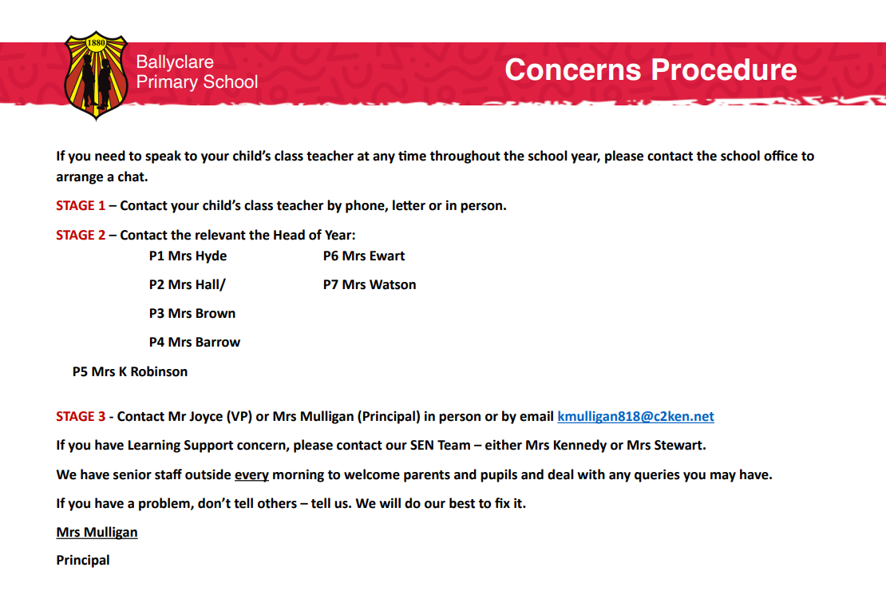

If you have escalated your concern as set out in the above flowchart and are of the view that it has not been addressed satisfactorily, you may revert to the school’s complaints policy. This policy should culminate in the option for you to contact the NI Public Services Ombudsman (NIPSO) who has the legislative power to investigate your complaint.
If a parent has a concern about a child’s safety or suspect child abuse within the local community, it should be brought directly to the attention of the Children’s Services Gateway Team.

APPENDIX 6
Procedure Where the School Has Concerns, or Has Been Given Information, about Possible Abuse by Someone Other Than a Member of Staff
Member of staff completes the Note of Concern on what has been observed or shared and must
ACT PROMPTLY.
Source of concern is notified that the school will follow up appropriately on the issues raised.

Designated Teacher clarifies/discusses concern with child/ parent/carers and decides if a child protection referral is or is not required.

Child Protection Referral Is Not Required

School may consider other options including monitoring the situation within an agreed timescale; signposting or referring the child/parent/carers to appropriate support services such as the Children’s Services Gateway Team or local Family Support Hub with parental consent, and child/young person’s consent (where appropriate).

Child Protection Referral Is Required

Designated Teacher seeks consent of the parent/carer and/or the child (if they are competent to give this) unless this would place the child at risk of significant harm then telephones the Children’s Services Gateway Team and/or the PSNI if a child is at immediate risk. He/she submits a completed UNOCINI referral form within 24 hours.

Where appropriate the source of the concern will be informed as to the action taken. The Designated Teacher will maintain a written record of all decisions and actions taken and ensure that this record is appropriately and securely stored.

Designated Teacher should consult with the Principal or other relevant staff before deciding upon action to be taken, always taking care to avoid undue delay. If required advice may be sought from a CPSS officer

Staff member discusses concerns with the Designated Teacher or Deputy Designated Teacher in his/her absence and provides note of concern.

APPENDIX 7

Dealing with Allegations of Abuse against a Member of Staff

KEY POINTS

Lead Individual learns of an allegation against a member of staff and informs the Chair/Vice Chair of BoG as appropriate.
Allegation addressed through relevant disciplinary procedures.

Alternatives to precautionary suspension imposed

Precautionary suspension under Child Protection procedures imposed

Precautionary suspension is not appropriate and the matter is concluded.

Possible Outcomes
Following on from establishing the facts, seeking advice from Key Agencies and discussion with the Chair and/or BOG to agree a way forward from the options below.
Guidance on the Next Steps
Lead individual then establishes the facts, seeks advice from the key agencies as appropriate, usually through informal discussion.

APPENDIX 8

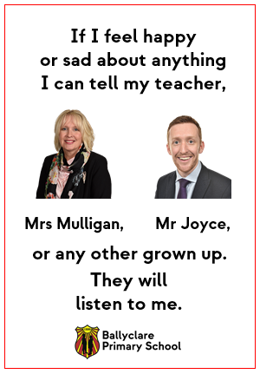

APPENDIX 9

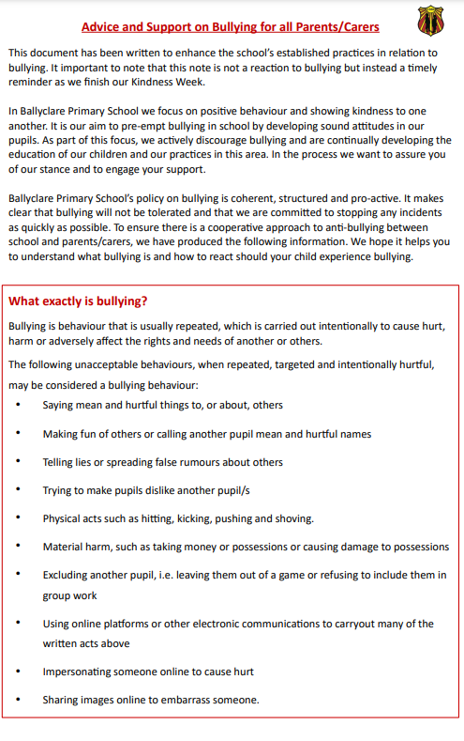

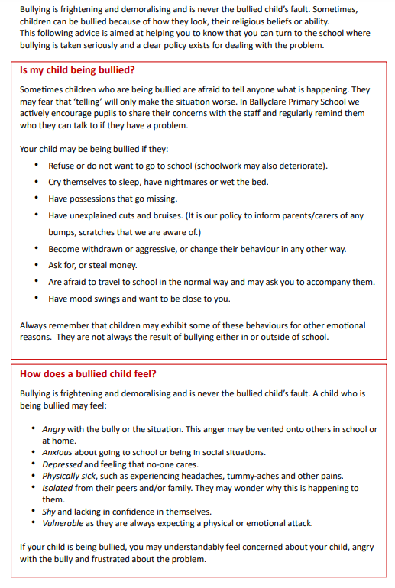
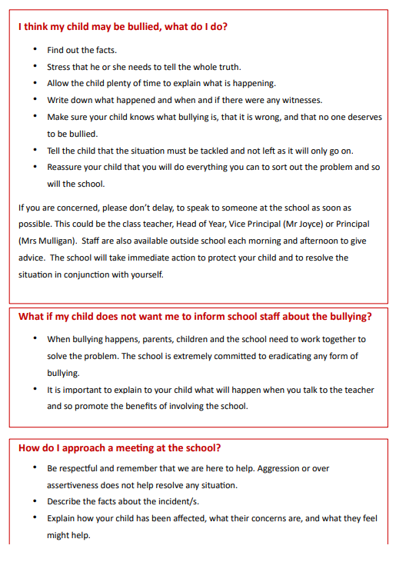

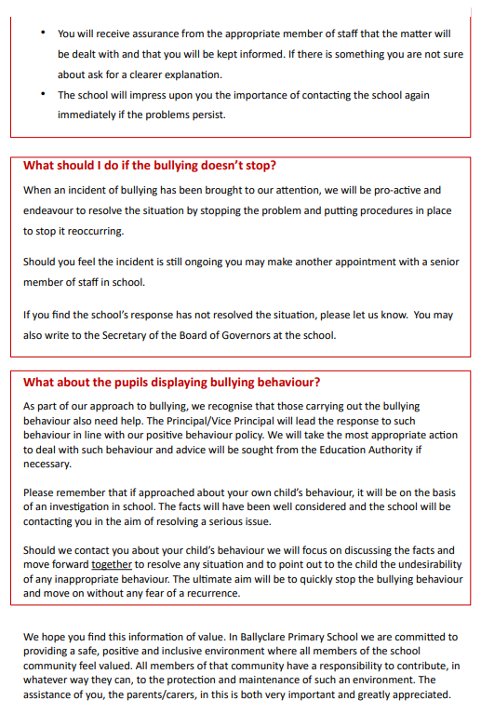

Co-Operating to Safeguard Children and Young People in Northern Ireland (March 2016) https://www.health-ni.gov.uk/publications/co-operating-safeguard-children-and-young-people-northern-ireland

